Scenario 1 - An integration between 2 systems using REST APIs and webhooks

## Task

You are a Junior Product Analyst at System A. You have been given permission to schedule some development work on System A to best achieve this integration. Design a data flow between the two systems to best achieve the above user experience flow. Include any triggers, events, requests and development items that will be executed. You are not required to use all available information.

## System A

System A is a Document Automation and E-signature System. Its core functionality revolves around the generation of documents that can then be electronically signed on the platform.

System A has the ability to call external APIs upon actions in the application. It also has a webhook endpoint to receive webhooks and trigger other potential actions.

## 

## System B

System B is a Document Management System. Its core functionality revolves around the storage of documents into different drives and folders created and managed by a user (similar to Google Drive or DropBox).

API authentication:

* Bearer token retrieved via System B’s UI.

Available API endpoints:

* Retrieval of drives and folder structure of a user.
* Create a new folder.
* Upload a file.
* Rename a file.

Available webhook trigger events:

* Folder has been created.
* File has been successfully uploaded.

## User experience flow

The client has requested a custom integration that would involve a user generating documents on System A and having them saved into System B. The client has the following requirements:

* Documents are manually generated on System A.
* After the initial generation, the first draft should be saved onto System B.
* Each time a new version of the document is saved, the new version should be saved onto System B.
* When the document is e-signed, the execution version of the document is saved onto System B as a .pdf file.
* When the execution version of the document has been saved onto System B, the document on System A should then be deleted.

Scenario 2 - Feature request

## Task

You are a Junior Product Analyst at System A. One of System A’s clients has come forth with a new use case that they’d like to use System A for. They’ve provided a list of business requirements (see below) that they need to achieve and would like System A to implement these requirements as a new feature. Using these requirements, we’d like you to write up a feature request for a new workflow action that can be provided to the development team for them to build. Take reference from the existing set-up page for the Add approver action when designing your spec.

## System A

System A is a Document Automation and Negotiation platform. One of its key features is the ability to create automated workflows that are triggered during the negotiation phase (e.g. automatically adding in an approver when the contract value is above a specified amount).

Sample existing workflow that the client uses:

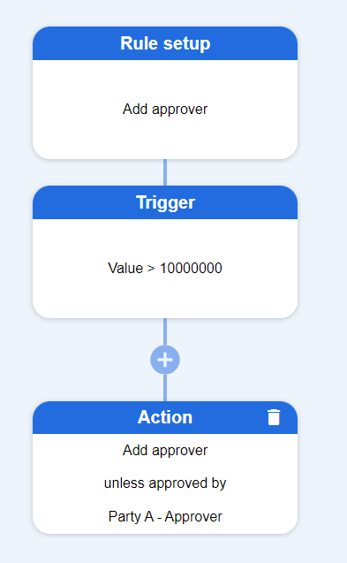

Sample existing workflow action set-up page for the Add approver action:

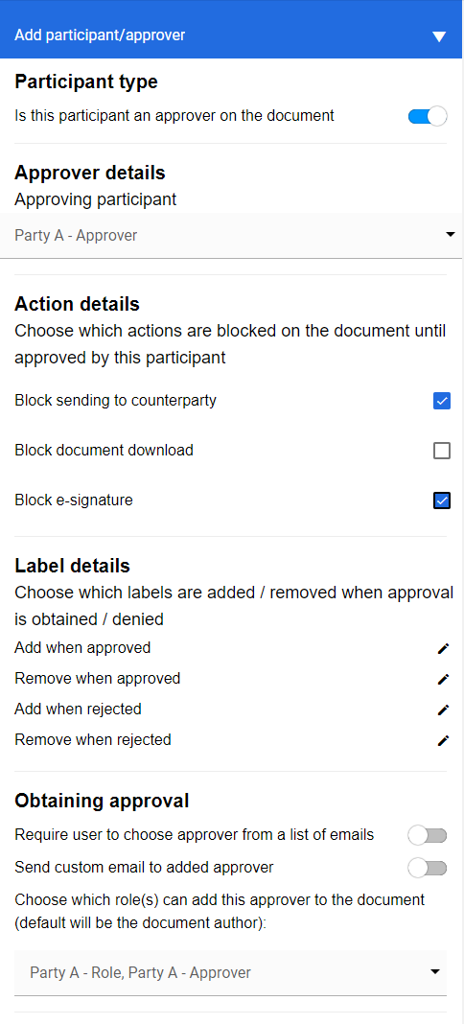

## Client business requirements

The client would like to be able to utilise these automated workflows to automatically schedule **reminder emails** that could go out on a schedule to predetermined recipients. Their user journey would be:

* User generates a document on System A.
* If the generated document has a Value > 10000000, it should trigger a reminder email to be sent to “[approver@client.com](mailto:approver@client.com)”.
* The client would like to be able to customise the content of the email.
* The client would like to customise the schedule that the reminder email would be sent out on.
  + The schedule set-up should include the ability to select a **specific number** of **days** or **business days** from the triggering of the workflow that the reminder email would be sent out.
  + The schedule set-up should include the ability to select the **time** and **time zone** of the day that the reminder email would be sent out.